**SESHADRI RAO GUDLAVALLERU ENGINEERING COLLEGE**

(An Autonomous Institute with Permanent Affiliation to JNTUK, Kakinada)

SeshadriRao Knowledge Village, Gudlavalleru

**IIIB.Tech II Semester(R20) Second Descriptive Examinations**

**Image Processing**

All questions carry equal marks. **3 × 5 = 15M**

1. **A) Explain about colour smoothing and sharpening process. [CO4; BL2](2M)**

# Colorimagesmoothing

* Extendspatialfilteringmasktocolorsmoothing,dealingwithcomponentvectors
* LetSxybetheneighborhoodcenteredat(x,y)
* AverageofRGBcomponentsintheneighborhoodisgivenby

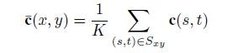

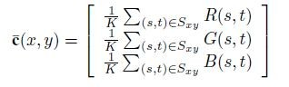Whichisthesameas

# Colorimagesharpening:

* + Image sharpening is done using the Laplacian. For vectoranalysis weknowthattheLaplacianofavectorisdefinedasavectorwhosecomponentsareequaltothelaplacianoftheindividualscalarcomponentsoftheinputvector.
  + 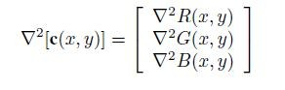InRGBcolorsystemtheLaplacianofvectoreisasfollows
  + IttellsusthatwecancomputetheLaplacianoffullcolorimagebycomputingtheLaplacianofeachcomponentimageseparately.

**B) Outline the basics of full color image processing. [CO4; BL2](2M)**

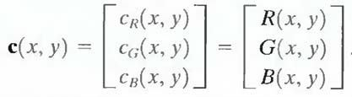 Full-color image processing approaches fall into two major categories. Inthe first category, eachcomponent image is processed individually andthenformacompositeprocessedcolorimagefromtheindividuallyprocessedcomponents.

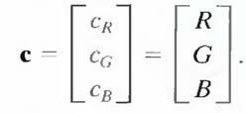

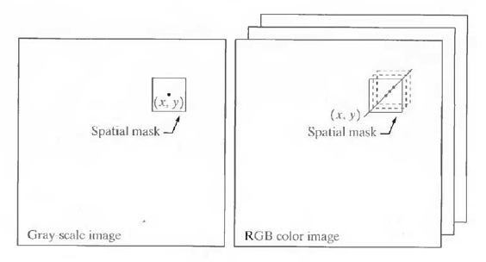 Inthesecond category,oneworkswithcolorpixels directly. Because full -color images have at least three components,colorpixelsreallyarevectors.

1. **A)Draw and explain image compression model. [CO3; BL4] (3M)**

Acompressionsystemconsistsoftwodistinctstructuralblocks:anencoderandadecoder.Aninputimagef(x,y)isfedintotheencoder,whichcreatesasetofsymbolsfromtheinputdata.Aftertransmissionoverthechannel,theencodedrepresentationisfedtothedecoder,wherea reconstructedoutputimagef^(x,y)isgenerated.Ingeneral,f^(x,y)mayormaynotbeanexactreplicaoff(x,y).Ifitis,thesystemiserrorfreeorinformationpreserving;ifnot,somelevelofdistortionispresentinthereconstructedimage.

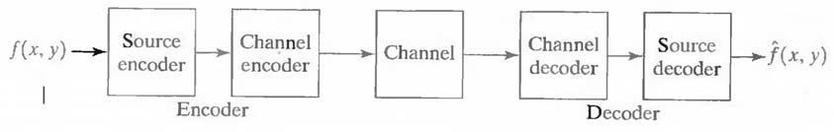

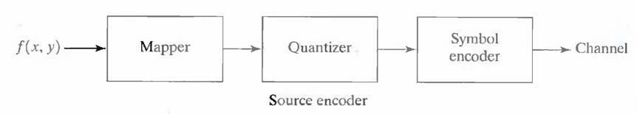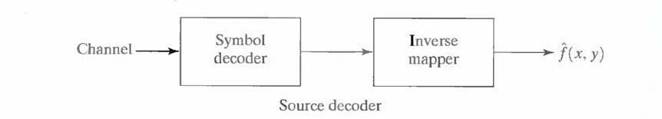

1. **A symbol source generates the symbols ｛a1,a2,a3,a4,a5,a6｝having the probabilities｛0.1,0.4,0.06,0.1,0.04,0.3} respectively. Using shannon-fanon coding and final average length and find efficiency. (2M)**

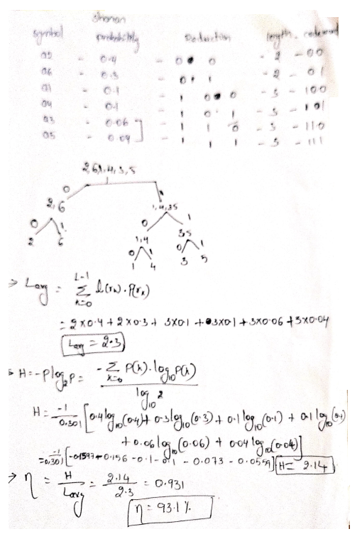

**3. A) Discuss briefly the region based segmentation. [CO3; BL2] (3M)**

The objective of segmentation is to partition an image into regions.

**RegionGrowing:**

Asitsnameimplies,**regiongrowing**isaprocedurethatgroupspixelsorsubregionsintolargerregionsbasedonpredefinedcriteria.Thebasicapproachistostartwithasetof"seed"pointsandfromthesegrowregionsbyappendingtoeachseedthoseneighbouringpixelsthathaveropertiessimilar totheseed(suchasspecificrangesofgraylevelorcolor).Whenaprioriinformationisnotavailable,theprocedureistocomputeateverypixelthesamesetofpropertiesthatultimatelywillbeusedtoassignpixelstoregionsduringthegrowingprocess.Iftheresultofthesecomputationsshowsclustersofvalues,thepixelswhosepropertiesplacethemnearthecentroidoftheseclusterscanbeusedasseeds.

**RegionSplittingandMerging:**

Theprocedurejustdiscussedgrowsregionsfromasetofseedpoints.Analternativeistosubdivideanimageinitiallyintoasetofarbitrary,disjointedregionsandthenmergeand/orsplittheregionsinanattempttosatisfytheconditions.Asplitandmerge algorithmthatiterativelyworkstowardsatisfyingtheseconstraintsisdeveloped.

**B) Write short notes on dilation, erosion, opening, closing. [CO5; BL2] (2M)**

**DilationandErosion**

Dilationanderosionarebasicmorphologicalprocessingoperations.Theyaredefinedintermsofmoreelementarysetoperations,butareemployedasthebasicelementsofmanyalgorithms. Bothdilationanderosionareproducedbytheinteractionof asetcalledastructuringelementwithasetofpixelsofinterestintheimage.Thestructuringelementhasbothashapeandanorigin.

**Dilation:**WithAandBassetinZ2,thedilationofAbyB,denotedAB,isdefinedas

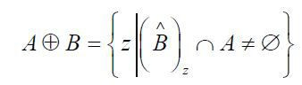

**Erosion:** GivenAandBsetsinZ2,theerosionofAbystructuringelementB,isdefinedby:



**Opening:** Theprocessoferosionfollowedbydilationiscalled**opening**.Ithastheeffectofeliminatingsmallandthinobjects,breakingtheobjectsatthinpointsandsmoothingtheboundaries/contoursoftheobjects.



**Closing:** Theprocessofdilationfollowedbyerosioniscalled**closing**.Ithastheeffectoffillingsmallandthinholes,connectingnearbyobjectsandsmoothingtheboundaries/contoursoftheobjects.ClosingofasetAbyseB,denotedbyA•B,isdefinedby

